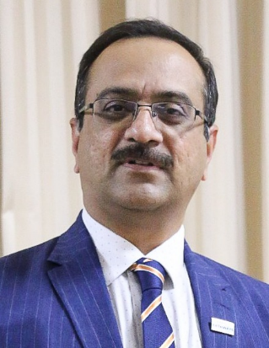
Ravishankar J
Nominee for Club Growth Director
Term 2021-2022
Membership Id: 03436426
Toastmaster since: 1st September, 2013
Current Membership:
- Indian Club Toastmasters (#727851) - since Sept. 2013
- Zeal Toastmasters Club (#6016430) – since Sep 2019
- Petra Toastmasters Club (#5474143) – since June 2020
Leadership Summary
July 2014 – June 2015 | Treasurer | Indian Club Toastmasters
July 2015 – June 2016 | VP Education | Indian Club Toastmasters
July 2016 – June 2017 | President | Indian Club Toastmasters
Jan 2017 – June 2017 | Acting Area 88 Director (in lieu of AD Ritesh) | Division S
July 2017 – June 2018 | Immediate Past President | Indian Club Toastmasters
July 2018 – June 2019 | Secretary | Doha Advanced Toastmasters
July 2018 – June 2019 | Assistant Division Director - PQ | Division B District 116P
2018 | Pathways Ambassador | District 20 Best Pathways Award
2019 | Logistics Chair DTAC Qatar | Qatar
July 2019 – June 2020 | Division Director | District 116
June 2020 – till date | District Administration Manager | District 116
Since Dec. 2016 | Coordinator | Indian Club Gaveliers

Other contributions:
- Exemplary service as Division Director.
- Appreciated for excellent coordination as District Administration Manager
- Pathways Ambassador (Best Ambassador in District 20)
- DTAC Qatar – 2019 Logistics Committee Chair
- Club Sponsor (Joeng Toastmasters)
- Club Mentor (McDermott Doha Toastmasters
- Key architect of ICTM-TMTM Speechcraft Program (2017)
I am a Chemical Engineer holding a senior and responsible position with technical expertise and leadership skills serving for Qatar Petroleum (refinery operations) in a corporate environment. I had to admit I had experience neither of public speaking nor of leading teams in non-profit organizations, prior to joining toastmasters.

I gained confidence & feel proud I have grown as one among top inspirational speakers within the Toastmasters community in Qatar. In past I have participated in speech contests regularly & have won 2nd place in Division H International Speech Contest in 2018. I strongly realize my ability to connect with the audience. Thanks to Toastmasters, I’ve been thrilled to see my evolution as a speaker, leader and a human being, over the last seven years or so.

I consider myself as excellent testimony for the transformation that happens to one who pursues his/her Toastmasters journey passionately and purposefully, as well as a good role model for servant leadership.

The tabular summary presented above gives a snapshot of the various leadership roles I have taken up so far. I can vouch for the fact that in each of these roles, I have always gone the extra mile, in pursuit of excellence and raising the bar. I enjoyed every success that followed my efforts.

I am is adept in developing strategies and executing them successfully. I have a knack of getting the best out team members, and generously placing them in limelight. My friends evaluate me as a good negotiator in commercial matters.

My current term as District Administration Manager have fostered my understanding more deeply on the roles and responsibilities of a District Leaders with highest Integrity.

To summarize, I feel confident to nominate myself for the position of District 116 Club Growth Director. I do have the expertise, experience, attributes and the right attitude essential for the position of Division Director. I am hopeful, I will add values to our young District to keep its flag flying higher and help it become one of the best preforming districts not just in Region 11, but across the globe.

My Best Regards
Ravishankar J

